PROJECT 1
ABOUT CUSTOMER
Name: pattani dhruvi
Date: 29-09-2026
PROJECT - 1
- CREATE TABLE QUERY
CREATE TABLE Customers (
CustomerID INT PRIMARY KEY,
CustomerName VARCHAR(100),
City VARCHAR(50)
);

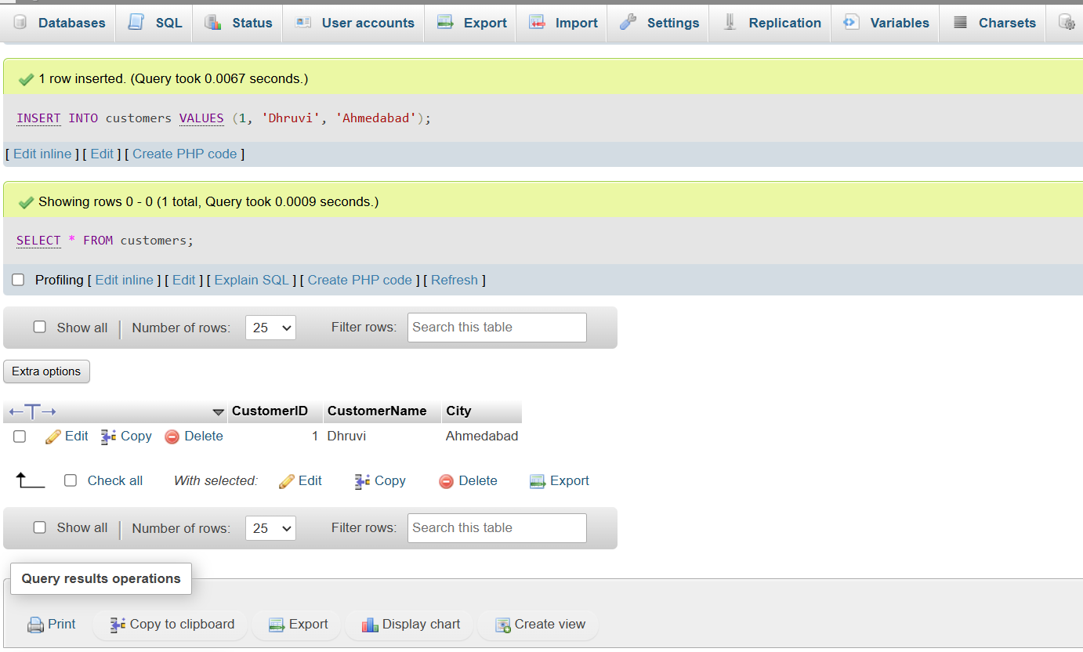
_{customers}
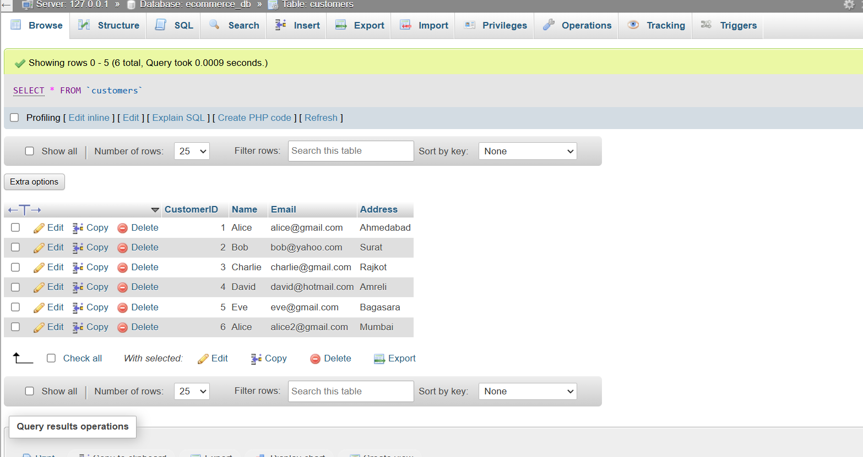
SELECT*FROM’CUSTOMERS’

orderDetils
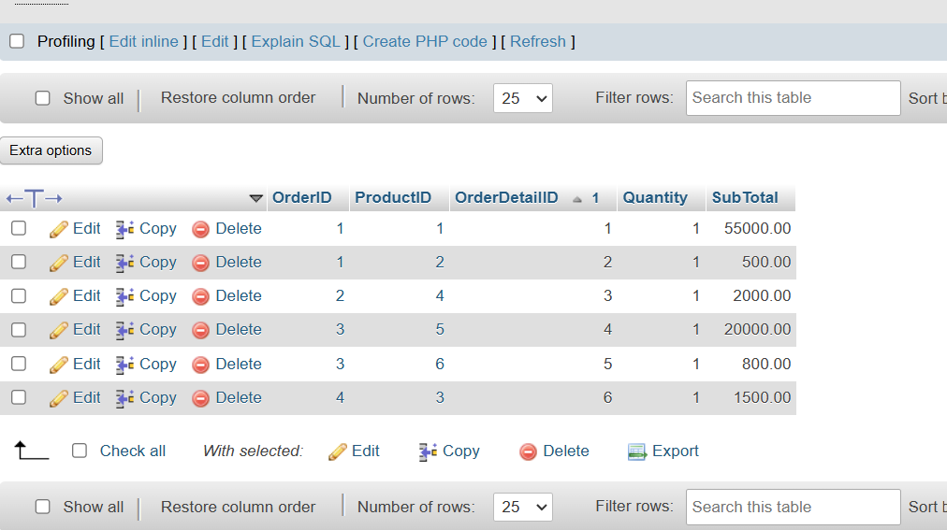

order
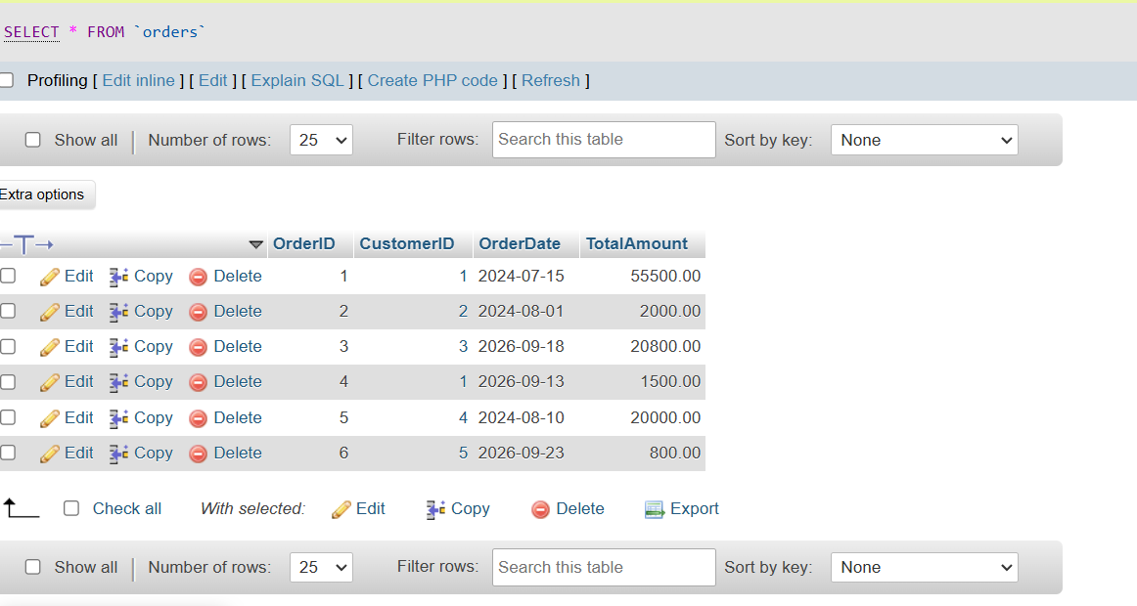
products
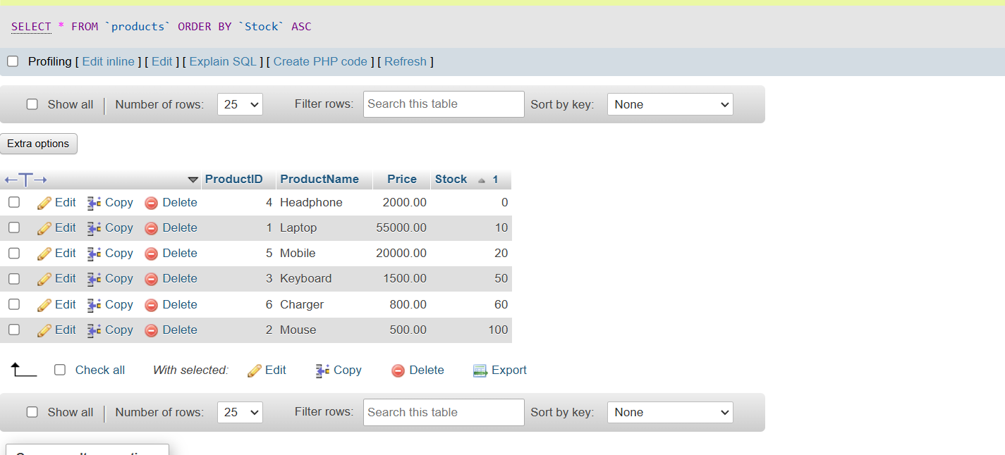

 | CustomerID 1 |  |  | Name |  | Email |  |  |  |  |  |  |  | Address
 |  |  |  |  | 1 |  | Alice | alice@gmail.com | Ahmedabad
 |  |  |  |  | 2 |  | Bob | bob@yahoo.com | Surat
 |  |  |  |  | 3 |  | Charlie | charlie@gmail.com | Rajkot
 |  |  |  |  | 4 |  | David | david@hotmail.com | Amreli
 |  |  |  |  | 5 |  | Eve | eve@gmail.com | Bagasara
 |  |  |  |  | 6 |  | Alice | alice2@gmail.com | Mumbai

o

